|  |  |  |
| --- | --- | --- |
| **Report IDM reference No.** | EFDA_D_2N7E4Y | **Version: see IDM** |

Final Report

on Deliverable

MAT-1.2.1-T006-D002 - PPPT EUROFER 97 Material Handbook 2016

|  |  |  |  |
| --- | --- | --- | --- |
|  | | **Deliverable-ID**[1] | MAT-1.2.1-T006-D002 |
| **Work Package** | *WPMAT* | **Date** | *31st Oct. 2016* |
| **Project Leader** | *Michael Rieth* | | |
|  | | | |
| **TS Title** | Summary overview report on Eurofer 97 MPH chapter support for year 2016 | | |
| **TS Ref. No.** | MAT-1.2.1-T006 | **TS IDM-link** | *EFDA_D_2N2C3C* |
| **Task Owner** | *Ferenc Gillemot* | | |
| **RU(s)** | *MTA EK* | | |

|  |  |
| --- | --- |
| **Report Review & Approval** | |
| **IDM role** | **Name(s)** |
| **Author** | Ferenc Gillemot |
| **Co-author(s)** | *Ildiko Szenthe, Attila Kovács* |
| **Reviewer(s)** | *Michael Gorley* |
| **PMU Reviewer** | *Eberhard Diegele, Matti Oron-Carl* |
| **Approver** | *Michael Rieth* |

|  |  |  |  |  |  |
| --- | --- | --- | --- | --- | --- |
| x | Study / Assessment |  | Procurement / Commissioning of Hardware |  | Industry |

|  |  |  |  |
| --- | --- | --- | --- |
|  | Use of Facility |  | Other *{please specify}* |

|  |
| --- |
| **Executive Summary** |
| MPH on EUROFER97 (grant deliverable) is ready for 2nd release after two years co-operative work of KIT and MTA EK. Organisational, content and editorial changes to the EUROFER97 MPH based on comments, and peer review are implemented. New data from the literature and enhanced analyses on some properties are also performed. This volume is a pilot volume for the DEMO structural materials MPH volumes, and the format can be used for other DEMO MPH-s. Revision recommended after 5 years, or when large number of new data will be collected. |

|  |
| --- |
| **Comments** (shortcomings, deviations, etc.) |
| *if any please shortly indicate here* |

*{Guidance on Report format given below, this is not mandatory and can be modified as required}*

**Table of Contents**

1 Short Introduction and Objectives of Work 2

2 Description of Work 3

3 Conclusion 6

4 References 6

**Abbreviations**

|  |  |
| --- | --- |
| *DEMO* | *Demonstration Fusion Reactor* |
| *MPH* | *Material Properties Handbook* |
| *MTA EK* | *Energy Reserach Centre of the Hungarian Academy of Sciences* |
| KIT | *Kasrlsruhe Institute of Technology* |

# Short Introduction and Objectives of Work

In 2014 MTA EK elaborated a format, content, and a sample file for the MPH. This file contained full size sample sheets of an structural material MPH chapter. Only one comment arrived from KIT, otherwise the format, and the content accepted. In 2015 the task was to elaborate a pilot chapter on EUROFER97. Decision have been made to use the existing database at KIT. The database access delayed since the safe delivery of it from KIT to MTA EK take time. When the database arrived MTA EK started the evaluation. Parallel with it KIT also made evaluation. MTA EK repeated all analyses made by KIT and extended it with own recommendations and analyses. Good co-operation started between the two institute and the first version of the pilot EUROFER MPH have been made until 31 December 2015. Unfortunately several decision have been made when the pilot version of the MPH have been ready. The file format have been changed for book format, and the points had to be deleted from the diagrams. If this decision would made when the format elaborated and the sample files provided some extra work, several late corrections would have been avoided.

In 2016 the task of MTA was : "Support from MTA to implement organisational, content and editorial changes to the EUROFER97 MPH based on comments and peer review of 2015 deliverable".

# Description of Work

Several changes have been performed on the pilot version of the MPH.

The changes can be divided into two groups: editorial changes and changes enhancement or extensions of the content.

The content have been extended some new property. The KIT structural material database mostly includes the mechanical properties, and the physical properties have been collected from the literature, or from reports. Several property have been re-analysed since the extension of collected knowledge. The analyses of the data is relatively easy in the case of standard as-received material. The main steps are as it follows: data collection and evaluation (whether is it acceptable high level data or outliner, if outliner can be important or is it erroneous?), after the data selection a function (generally an polynomial have to be fit on the data to get the average trend curve. The proper selection of the polynomial level is important: if it is too high the use of it difficult, if the level is not high enough the fit may causes deviations from the real values. Also the decimals of the fitting constants have to be carefully selected. Too many decimals are not user friendly, too few causes errors in the calculated values. Sensitivity analyses used to find the best compromise. The final step was to elaborate the diagrams and tables of the property.

Working with aged EUROFER the is more difficult. There are several parameters to consider: irradiation fluence, spectra, flux, temperature, testing temperature. The designers minimum requirement to know every material property in the function of operating temperature and fluence. The available number of combinations are too large to measure all, and long term irradiations are very expensive and time consuming. Since the irradiations performed in different reactors (different spectra, different flux, different irradiation temperature) the scatter of the data are large. The only way of the evaluation is to make groups from the available data and provide the average curves. Several grouping may be made from the available limited number of data. To select the best grouping many attempt and considerations, knowledge of the ageing mechanism is required. After proper grouping the procedure of analyses for every group is the same as in the case of as received material. (See figure 1).

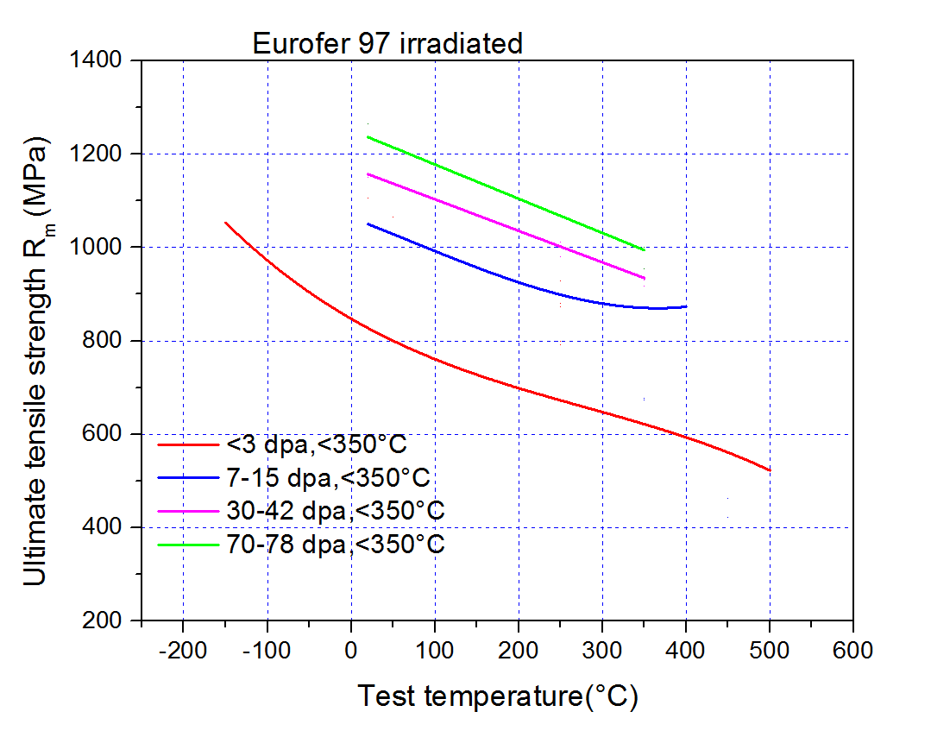

***Figure1****. Irradiated Eurofer data filtered into groups according to the fluence values.*

In case of literature data the first step is evaluate the reliability and usefulness. Many paper, conference presentation (and sometimes research report too!) doesn't identify properly the tested material or the ageing conditions. Such data are not, or only after comparison with other data can be used for prepare a design trend curve. Some data are correctly published, but not useful for preparing trend curve for designers.

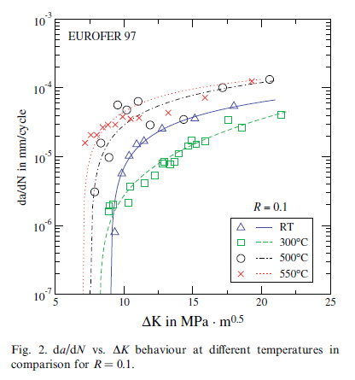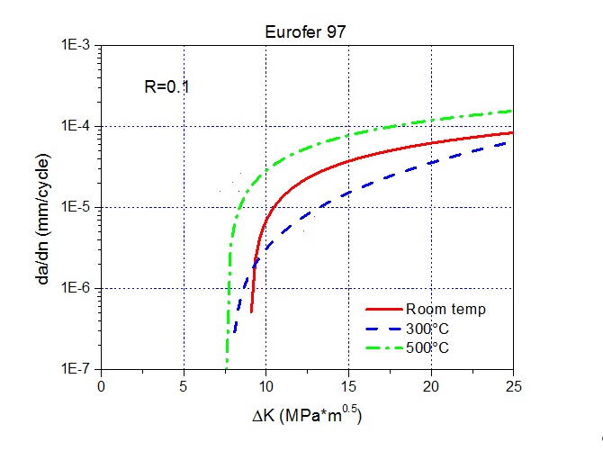

***Figure 2****. The original published picture on fatigue crack growht (left) and the figure in the MPH (right). The difference is the points measured at 550°C deleted, since the explanation of the strange behavor is too difficult, and may mislead the user without metallographic knowledge*. *[20]*

The EUROFER MPH elaborated mostly in 2015 in co-operation between KIT and MTA EK. Analyses made by one institute had been repeated by the other one. Differences between the solutions or calculations discussed and solved. This is a basic step of quality insurance. Many times the way of analyses have been discussed personally, or by e-mail exchange, by VC.

In 2016 the planned task was to finalise the document, mainly editing according to the advices of the designers. Finally much more work performed, again in close co-operation between KIT and MTA EK. The short description of the tasks fulfilled at 2016:

Design allowances have been included into the EUROFER MPH. The inclusion of the design allowances were not planned in the original format (they are not material properties, since they can be calculated from the material properties according to the relevant design code. The ITER MPH isn't contained design allowances. The advantage to include design allowances is extra information for the designers, the disadvantages, that the different codes may use different design allowances and it can mislead the designers in future). The inclusions of them required to take into separate paragraphs of them, to separate from the measured material properties, since the use of them is different.

Several material property analyses reviewed, and three new property included. As an example see figure 3.

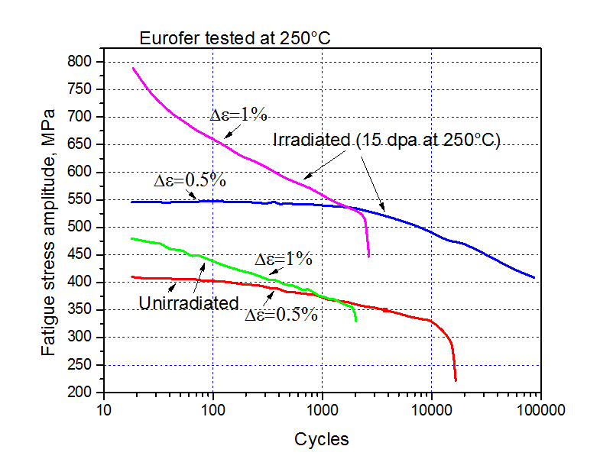

***Figure 3****. Comparison of low-cycle fatigue toughness of as received and irradiated Eurofer. (simplified diagram based on literature [14] )*

Typical editorial changes was to renumber of the figures. The inconvenience of the book format is that any corrections or extensions change the list of content, reference list, and the number of the figures and tables. The advantage of the book format is easier to use than the sheet format. The difficulties since the book format partially have been solved by using chapter numbers before the figure and table numbers. The another suggestion was to organise the property sheets (in book now called chapters) in order of meanings (mechanical properties, physical properties etc.) . It also took efforts, 75 pages of the book had to be re-ordered.

It was requested, that only the trend curves can be published, the measured data points shouldn't be in the figures. More than 70 figures had to be changed.

The present version of the EUROFER MPH contains 25 files and trend curves or data for the following 22 mechanical and physical properties:

1. General information on EUROFER97
2. Chemical composition
3. Density
4. Yield strength
5. Tensile strength
6. Elongation
7. Reduction of area
8. Young’s modulus
9. Poisson’s ratio
10. CHARPY impact energy
11. Fracture toughness
12. Fatigue-crack-growth rate
13. Fatigue
14. Creep
15. Linear thermal expansion
16. Thermal conductivity
17. Thermal diffusivity
18. Specific heat
19. Electrical resistivity
20. Magnetic saturation
21. Remnant magnetization
22. Coercive field

Empty chapters prepared also for Swelling, Ratchetting, and Melting temperature, due to the lack of data.

# Conclusion

The EUROFER MPH is ready after two years good co-operation of KIT and MTA EK. It have been elaborated on the base of structural materials database (supplied by KIT) and using the open literature.

# References

# Nadine Baluc:”Reduced Activation Materials”, Presentation, Centre of Research in Plasma Physics Association EURATOM - Swiss Confederation Swiss Federal Institute of Technology - Lausanne

1. E. Gagarnidze: “Final report on PPPT Material Property Handbook on Eurofer” (KIT, 2015)
2. R. Lindau, A. Möslang, M. Rieth, M. Klimenkou, E. Materna-Morris, A. Alamo, F. Tavassoli, C. Cayron, A.-M. Lancha, P. Fernandez, N. Baluc, R- Schäublin, E. Diegele, G. Filacchioni, J.W. Rensman, B.v.d. Schaaf, E. Lucon, W. Dietz: "Present development status of EUROFER and ODS-EUROFER for application in blanket concepts" Fus. Eng. Design 75-79 (2005) 989-996.
3. F. Tavassoli: “Comparison of 316L(N) -IG and Eurofer for Early DEMO”. EFDA-WP13-MAT-02-01
4. N.V. Luzginova, J.-W. Rensman, M. Jong, P. ten Pierick, T. Bakker, H. Nolle: “An Overview of 10 Years of Irradiation Experiments on Eurofer97 Steel at High Flux Reactor in Petten” Journal of Nuclear Materials Volume 455, Issues 1–3, Pages 1-73 (December 2014)
5. F. Tavassoli, B. Fournier, M. Sauzay, “High Temperature Creep-Fatigue Design”, in Transactions of The Indian Institute of Metals, April 2010, Vol. 63, issue 2-3, pp. 235-244.
6. F. Tavassoli, “Eurofer Steel, Development to Full Code Qualification”, in 6th International Conference on Creep, Fatigue and Creep-Fatigue Interaction [CF-6], Procedia Engineering 55 (2013) 300-308
7. J-L. Séran, A. Alamo, A. Maillard, H. Touron, P. Dubuisson, and O. Rabouille: “Post- irradiation mechanical properties of ferritic-martensitic steels for fusion”
8. F. Tavassoli, E. Diegele, R. Lindau, N. Luzginova, H. Tanigawa:” [Current status and recent research achievements in ferritic/martensitic steels](http://www.sciencedirect.com/science/article/pii/S0022311514003742)” Journal of Nuclear Materials Volume 455, Issues 1–3, p. 269-276
9. J. Henry, X. Averty, A. Alamo, “Mechanical properties of Reduced Activation steels irradiated in BOR-60 at 325°C up to 78 dpa”, Dec. 2008, Final Report – TW5-TTMS-001-D03
10. P. Aubert, F. Tavassoli, M. Rieth, E. Diegele, Y. Poitevin, “Low activation steels welding with PWHT and coating for ITER test blanket modules and DEMO”, in Journal of Nuclear Materials 409 (2011) 156–162
11. E. Lucon,[Rachid Chaouadi](http://www.sciencedirect.com/science/article/pii/S0022311504001539), [Marc Decréton](http://www.sciencedirect.com/science/article/pii/S0022311504001539): “Mechanical properties of the European reference RAFM steel (EUROFER97) before and after irradiation at 300 °C” in [Journal of Nuclear Materials](http://www.sciencedirect.com/science/journal/00223115), vol. [329–333, Part B](http://www.sciencedirect.com/science/journal/00223115/329/supp/PB), 1 August 2004, Pages 1078–1082
12. F. A. Moeslang, E.Diegele, M. Klimankov, R. Laesser, R. Lindau, E. Lukon, et al Nuclear Fusion 45 (2005) 649-655
13. E. Materna-Morris, A. Möslang, H.-C. Schneider: "Tensile and low cycle fatigue properties of EUROFER97-steel after 16.3 dpa neutron irradiation at 523, 623 and 723 K", Journal of Nuclear Materials, 442 (2013) S62-S66.
14. C. Petersen: "Post irradiation examination of RAF/M steels after fast reactor irradiation up to 33 dpa and < 340°C (ARBOR 1)". Karlsruher Institut für Technologie. 2010. FZKA 7517.
15. E. Gaganidze, C. Petersen: "Post irradiation examination of RAFM steels after fast reactor irradiation up to 71 dpa and <340 °C (ARBOR 2)". Karlsruhe Institute of Technology, KIT Scientific Report 7596. 2011.
16. N. Ilchuk, P. Spätig, G.R. Odette: "Fracture toughness characterization in the lower transition of neutron irradiated EUROFER97 steel", Journal of Nuclear Materials 442 (2013) S58–S61
17. F. Tavassoli, “Eurofer Steel, Development to Full Code Qualification”, in 6th International Conference on Creep, Fatigue and Creep-Fatigue Interaction [CF-6], Procedia Engineering 55 (2013) 300-308
18. P. Mueller, P. Spätig, R. Bonadé, G.R. Odette, D. Gragg: "Fracture toughness master-curve analysis of the tempered martensitic steel Eurofer", J. Nucl. Mater. 386-388 (2009) 323-327.
19. J. Aktaa , M. Lerch: "Near-threshold fatigue crack behaviour in EUROFER97 at different temperatures", Journal of Nuclear Materials 353 (2006) 101–108
20. J. Aktaa, M. Weick, C. Petersen: "Reduced softening of EUROFER97 under thermomechanical and multiaxial fatigue loading and its impact on the design rules" , Journal of Nuclear Materials 386–388 (2009) 911–914
21. Pierre Marmy, Tomas Kruml: "Low cycle fatigue of EUROFER97", Journal of Nuclear Materials 377 (2008) 52–58
22. M. Rieth, M. Schirra, A. Falkenstein, P. Graf, S. Heger, H. Kempe, R. Lindau, H. Zimmermann. "EUROFER97, Tensile, Charpy, Creep and Structural Tests". Forschungszentrum Karlsruhe. 2003. Wissenschaftliche Berichte. FZKA 6911.
23. E. Materna-Morris, Ch. Adelhelm, S. Baumgärtner, B. Dafferner, A. Falkenstein, S. Heger, R. Lindau, P. Graf, C. Petersen, M. Rieth, R. Ziegler, H. Zimmermann: "Structural Material EUROFER97-2, Characterization of 100 mm Rod Material: Structural, Tensile, Charpy, and Creep Properties". Forschungszentrum Karlsruhe. 2006. Report on EFDA Task TW4-TTMS- 005 D2. Interner Bericht 31.40.04, Fusion No. 265.
24. M. Rieth, S. Hegger: "Creep Properties of EUROFER97" [Hrsg.] KIT. private communication. 2015.
25. L. Séran, V. Lévy, P. Dubuisson, D. Gilbon, M. P. Hugon, A. Maillard, A. Fissolo, H.Touron, R. Cauvin, A. Chalony, and E. Le Bouilbin: "Behavior under Neutron Irradiation of the 15-15Ti and EM10 Steels Used as Standard Materials of the Phénix Fuel Subassembly" in Effect of Radiation on Materials: 15th International Symposium, ASTM STP 1125, R. E. Stoller, A. S. Kumar, D. S. Gelles, Eds, Am. Soc. for Testing Materials, Philadelphia, 1992, 1209-1233.
26. K. Mergia, N. Boukos: "Structural, thermal, electrical and magnetic properties of Eurofer97 steel", J. Nucl. Mater. 373 (2008) 1-8

1. One *Deliverable Report* shall be submitted for each deliverable e.g. Study Report, Commissioning Report, Final Assessment Report, Technical Acceptance Report, Procurement Report, etc.